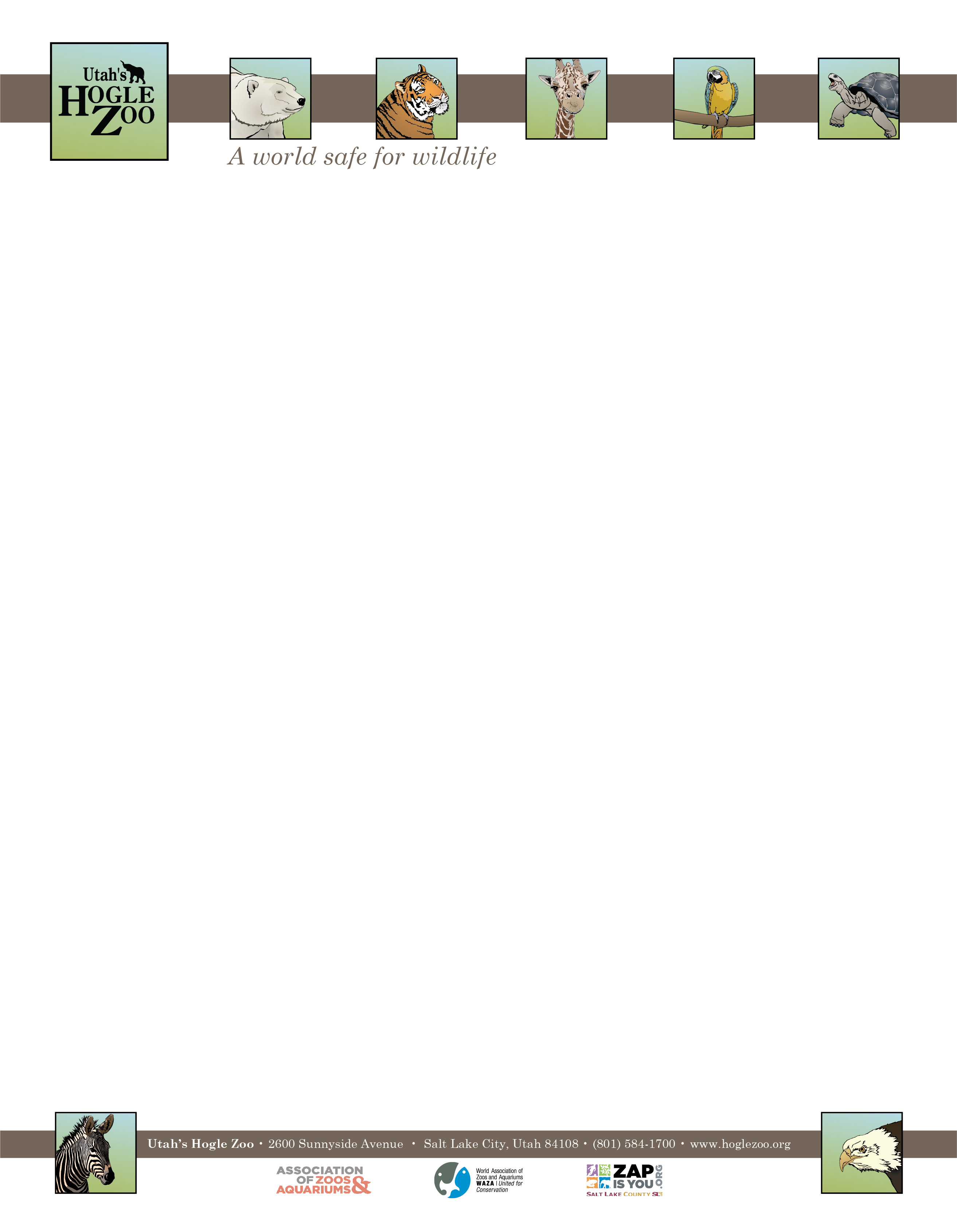

**Organization:** Utah’s Hogle Zoo (AZA Member) **Unpaid Internship:** Special Events Internship

**Location:** Salt Lake City, Utah, United States

**POSITION SUMMARY:**

This internship program is designed to provide learning opportunities and practical experience while gaining valuable knowledge relating to a career in Public & Private Events. The Special Events Intern will assist the Special Events Team with the daily preparation and facilitation of revenue-generating public and private events, and assist with a wide range of other event duties. This internship offers a hands-on opportunity to work with Special Event professionals in a zoological setting. A commitment of 10 weeks is required. This is an unpaid position and no housing is provided.

**REPORTS TO:** Special Event Coordinators

**DATES:** May 16th- August 22nd, 2022

**POSITION DESCRIPTION:**

The Special Event Internship program is designed to provide participants with practical learning experience and knowledge in the field of Public & Private Events. In return, the intern makes a significant contribution to the guest experience. Intern duties may include planning and implementation including, but not limited to the procurement of supplies, booking of entertainment, set-up and breakdown.Duties may vary based on skill level and departmental needs:

1. Design and implement new plans and ideas for special events, including the concepts of conservation, education, and entertainment.
2. Assist the Special Events Team with planning, set up, and tear down of Zoo Brews, one of our big fundraisers.
3. Reach out to organizations and individuals for the procurement of auction items and entertainment.
4. Assist with miscellaneous tasks as assigned.
5. Submit weekly task summary to Special Event Supervisor (if applicable with course description)

**GOAL:** Interns will understand the roles and duties of Special Event staff in a Zoological setting.

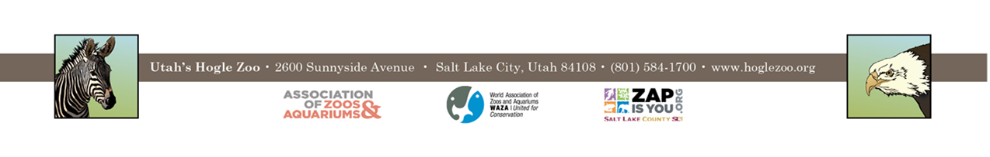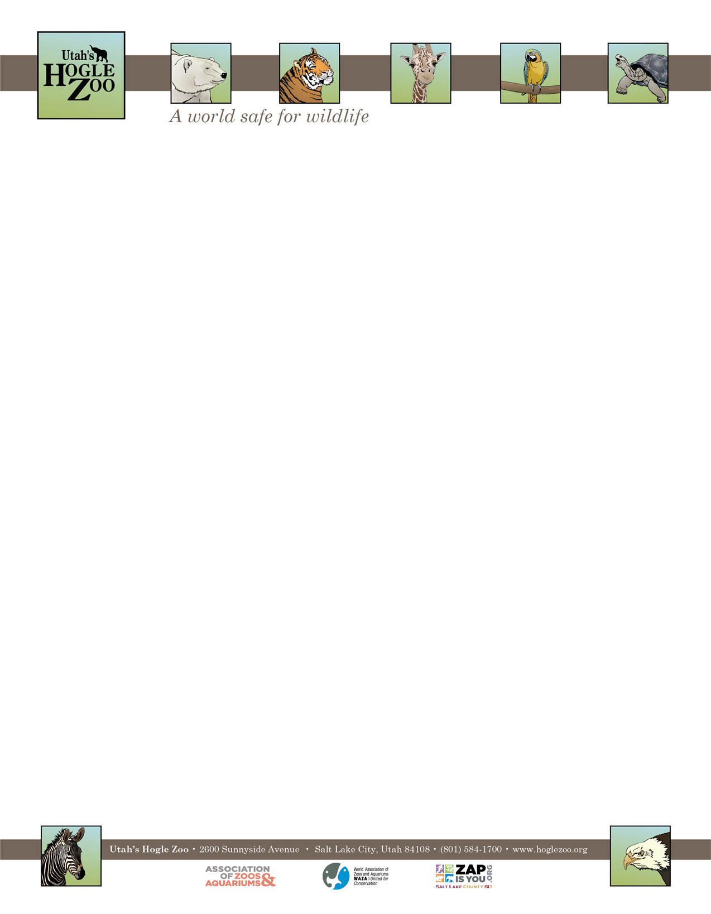

**OBJECTIVES:**

* Plan and execute smaller event of your choosing with the help of the Special Event Coordinators.
* Incorporate at least one educational element into your assigned events.
* Learn how to utilize the Zoo’s resources for event planning.
* Learn how special events are developed and executed.
* Participate in all special events during your internship time frame (will include some weekend and evening events).

**QUALIFICATIONS:**

Be currently enrolled in a college or university, or have recently graduated. Have a minimum of one year of course work in a major field of study to be applied during the internship (e.g. communications, event coordinating, tourism, etc.). Demonstrated enthusiasm for and interest in working in events, with Zoo visitors, and Zoo animals. Interns need to have a recent TB test, and a tetanus shot is highly recommended. Because of the nature of working with guests, sponsors and donors, the applicant needs to demonstrate maturity, self-motivation, and an ability to follow direction. Interns must be 21 and older for this internship due to the nature of some events. A basic knowledge and understanding of computer word processing and Outlook is helpful. Must be able to lift and carry tables, light figures, chairs, tents that could weigh up to 50 pounds. Willing to work outside in a variety of weather conditions.

**WORK SCHEDULE:** Ideally work 20-40 hours a week for a minimum of 10 weeks. Interns are expected to work various Saturdays, evenings and holidays. Schedule can be varied if necessary. The position will be Mon-Fri, with the occasional Saturday.

**COMPENSATION:** The Special Event Internship is unpaid. Professional development opportunities will be available. Possible college credit is available for those able to receive it through their college/university. No housing provided.

**TO APPLY:** Applications are due by **February 14, 2022**.

Please visit <https://www.hoglezoo.org/jobs_volunteers/internships/> to fill out an application. In addition to completing the application send a resume, cover letter, and informal transcript to [volunteeroffice@hoglezoo.org](mailto:volunteeroffice@hoglezoo.org)  .

Applicants will be contacted for interviews at the end of February, please do not expect to hear from us before then.

Please e-mail volunteeroffice@hoglezoo.org with any questions.

Further questions about the position may be directed to:

Kennedy Gray

Special Event Coordinator

Utah’s Hogle Zoo

**Email:** kgray@hoglezoo.org

**Utah’s Hogle Zoo is committed to providing a diverse and inclusive internship program representative of a variety of backgrounds, age groups, perspectives, experiences, abilities, and strengths.**