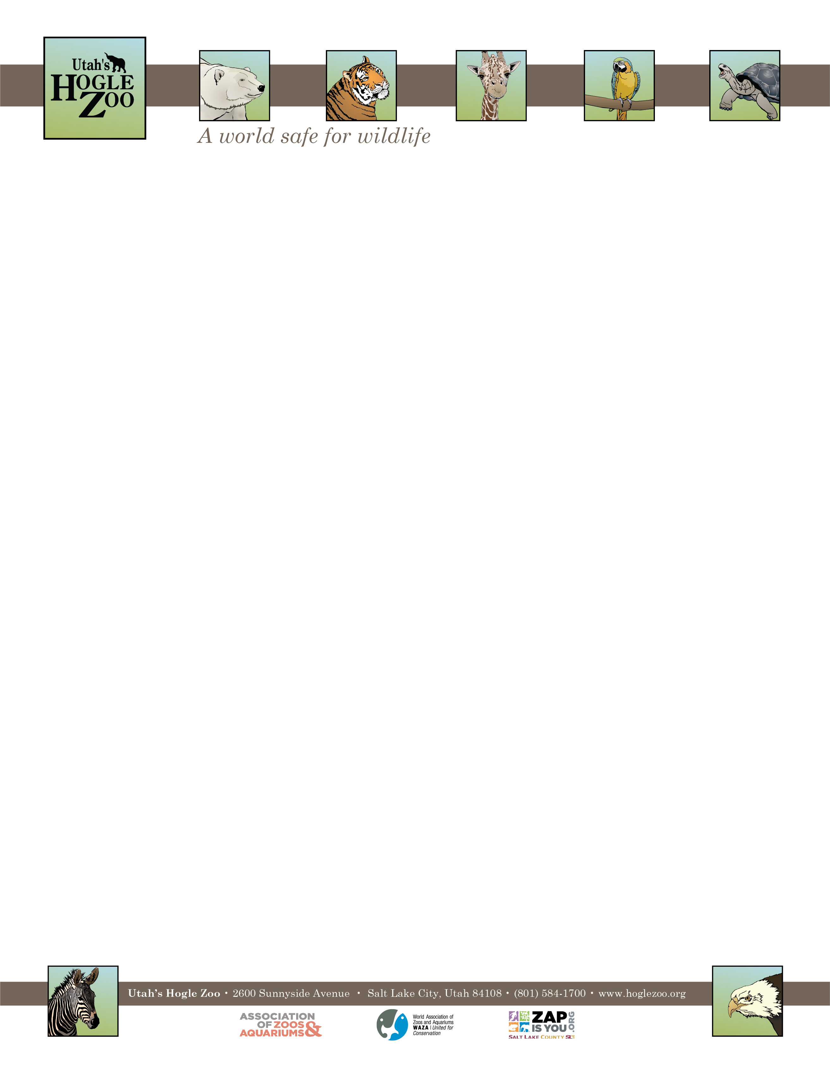

**Organization:** Utah’s Hogle Zoo (AZA Member) **Unpaid Internship:** Education Internship (2 positions available)

**Location:** Salt Lake City, Utah, United States

**POSITION SUMMARY:**

This internship program is designed to provide learning opportunities and practical experience while gaining valuable knowledge relating to a career in informal education. The Education Intern will assist the Education staff with the daily preparation and facilitation of summer camps, and assist with a wide range of other educational duties. This internship offers a hands-on opportunity to work for an education department in a zoological setting. A commitment of 10 weeks is required. The position will be from 8:00-4:30 and 5 days a week with flexibility on the days scheduled. This is an unpaid position and no housing is provided.

**REPORTS TO:** Director of Education

**DATES:** May 23- August 15, 2022 (start and end date may be flexible based on school schedule)

**POSITION DESCRIPTION:**

The Education Internship program is designed to provide participants with practical learning experience and knowledge in the field of informal education. In return, the intern makes a significant contribution to the Education Department. Intern duties may include the following (may vary based on skill level and departmental needs):

1. Assist the education staff in the supervision and instruction of summer camp participants. Lead camp activities as requested.
2. Assist education staff in the daily and weekly set-up, clean-up, and facilitation of each program.
3. Design and implement classroom projects, activities and games for summer camps.
4. Design and write the curriculum for a one-day camp program with support from the education staff.
5. Learn the proper handling protocols of Tier 1 education ambassador animals. Handle animals as part of an interpretive talk for guests and camp students.
6. Assist the education staff in coordinating and presenting special day events on site.
7. Assist with miscellaneous tasks as assigned.
8. Keep a weekly journal of their activities and observations

**GOAL:** Interns will understand the roles and duties of an informal educator in a Zoological setting.

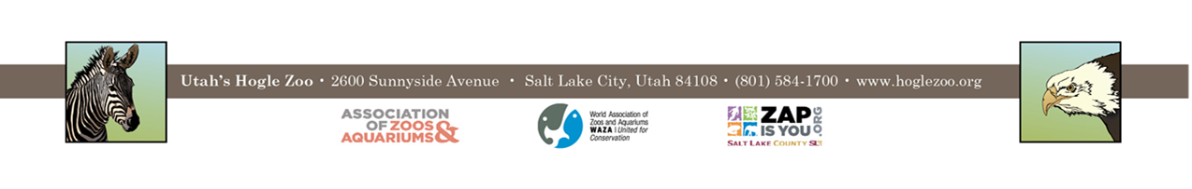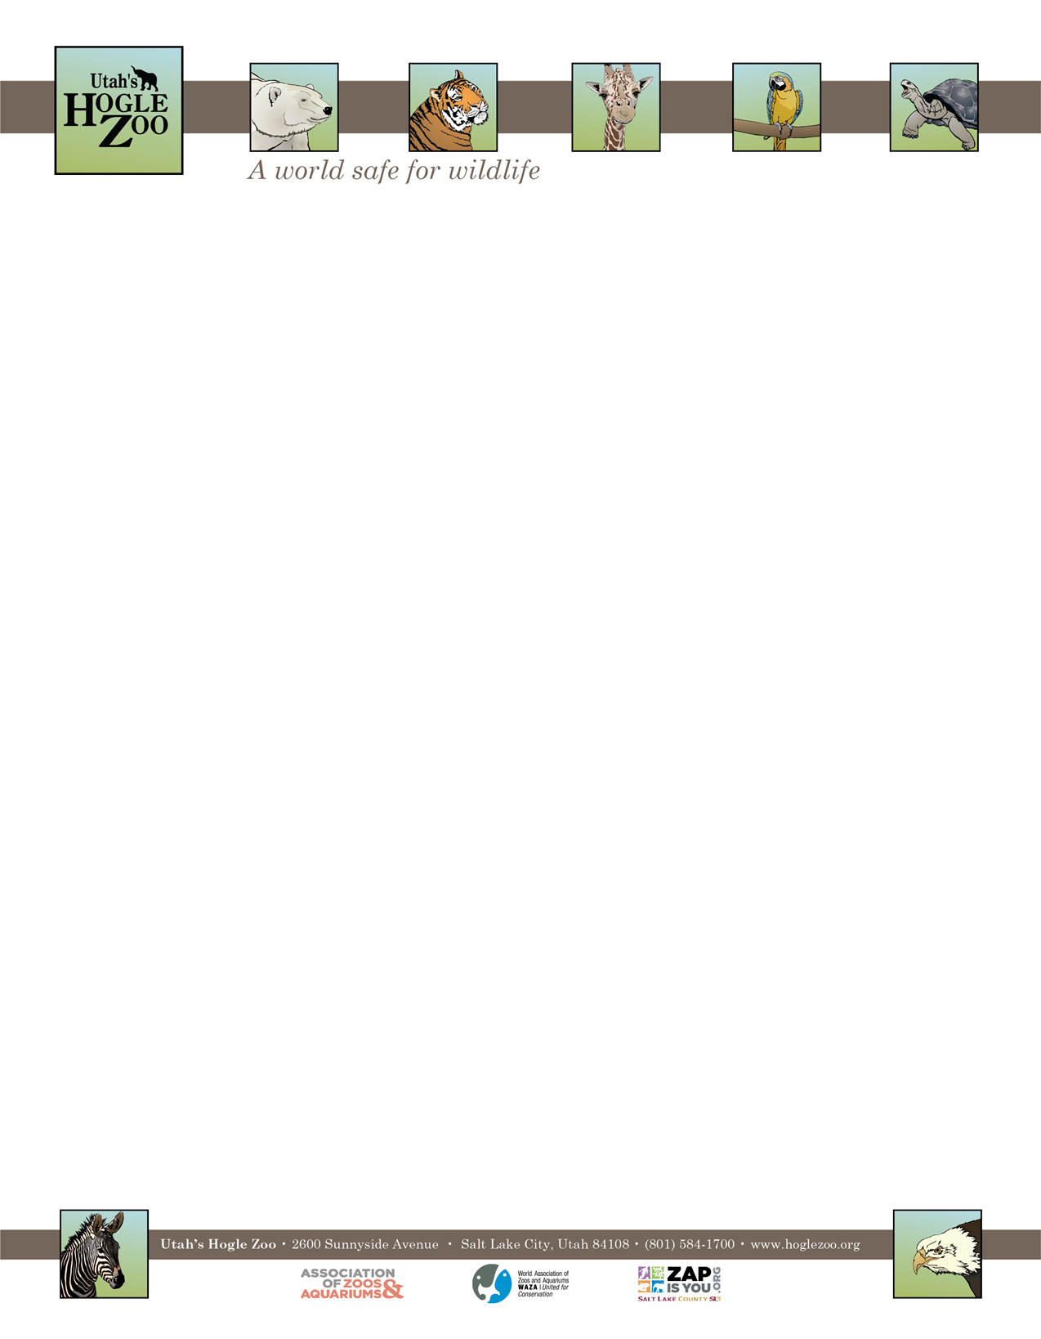

**OBJECTIVES:**

* Learn how to write lesson plans for informal education.
* Learn classroom management skills for a range of ages.
* Give an interpretive talk using live education ambassador animals.
* Learn how to utilize the Zoo’s resources for lessons.
* Learn how summer camps are developed and executed.
* Present a lesson in summer camp.
* Participate in a wide variety of education classes.

**QUALIFICATIONS:**

Be currently enrolled in a college or university, or have recently graduated. Have a minimum of one year of course work in a major field of study to be applied during the internship (e.g. education, biology, zoology, environmental science, etc.). Experience working with children ages 4-12 a plus. Demonstrated enthusiasm for and interest in working with children, Zoo visitors, and Zoo animals. Interns need to have a recent TB test, and a tetanus shot is highly recommended. Interns must complete Youth Protection Training before start date. Because of the nature of working with and close to a variety of animals, the applicant needs to demonstrate maturity, self-motivation, and an ability to follow direction. A basic knowledge and understanding of computer word processing and PowerPoint is helpful.

**WORK SCHEDULE:** Ideally work 40 hours a week for a minimum of 10 weeks. Interns are expected to work various Saturdays and holidays. Schedule can be varied if necessary.

**COMPENSATION:** The Education Internship is unpaid. Professional development opportunities will be available. Possible college credit is available for those able to receive it through their college/university. No housing provided.

**TO APPLY:** Applications are due by **February 14, 2022**.

Please visit <https://www.hoglezoo.org/jobs_volunteers/internships/> to fill out an application. In addition to completing the application send a resume, cover letter, and informal transcript to [volunteeroffice@hoglezoo.org](mailto:volunteeroffice@hoglezoo.org)  .

Applicants will be contacted for interviews at the end of February, please do not expect to hear from us before then.

Further questions about the position may be directed to:

Angelina Kump

Lead for Teacher Professional Development

Utah’s Hogle Zoo

**Email:** [akump@hoglezoo.org](mailto:akump@hoglezoo.org)

**Utah’s Hogle Zoo is committed to providing a diverse and inclusive internship program representative of a variety of backgrounds, age groups, perspectives, experiences, abilities, and strengths.**