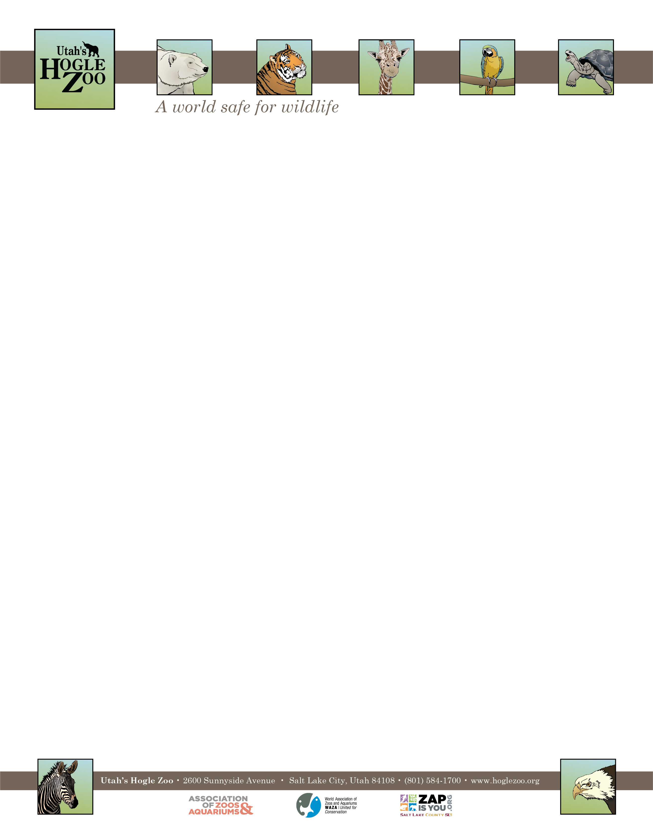

**Organization:** Utah’s Hogle Zoo (AZA Member) **Internship:** Diversity in Field Conservation Internship

**Location:** Salt Lake City, Utah, United States

**POSITION SUMMARY:**

This internship program is designed to provide learning opportunities and practical experience, while gaining valuable knowledge relating to a career in wildlife conservation. Working in the Conservation Department alongside the Utah Conservation Programs Supervisor and the Conservation Action Coordinator, this internship offers a hands-on opportunity to work in a conservation program in a zoological setting and aims to give applicants insight into the field of conservation biology with case study and practical experience within the conservation efforts of Utah’s Hogle Zoo.

Most field work will focus on amphibians, in particular the boreal toad. Our aim is to conduct visual encounter surveys across their state range to monitor known populations, as well as; determine presence at sites historically known to be inhabited, identify breeding ponds and discover potential habitat for future reintroduction programs.

Other field work will include: restoration activities along the Jordan River, trail camera maintenance, photo sorting and animal identification, as well as helping with on grounds community science activities such as Caterpillars Count, and staffing conservation tables at Zoo events.

As is the nature of field work, do not expect a 9-5 Monday- Friday schedule. Multiple overnight trips are planned along with a few weekend trips, including Sundays. As an intern we expect you to be working 32-40 hours a week but we also understand your other commitments and will accommodate flexibility within reason.

This internship is based at Utah’s Hogle Zoo in Salt Lake City, but work will frequently take us all over the state of Utah. Transportation and food in the field will be provided. The Zoo will also provide all necessary field equipment (boots and camping gear). There is no housing provided with this internship.

For a conservation strategy to be effective it must be diverse and comprehensive in its nature. Often involving multiple stakeholders with differing values and ideas, without a cohesive and inclusive management plan conservation simply cannot be done. The field of conservation does not currently reflect the communal voice of those championing for it. Please see below for information on our Diversity in Conservation Scholarship.

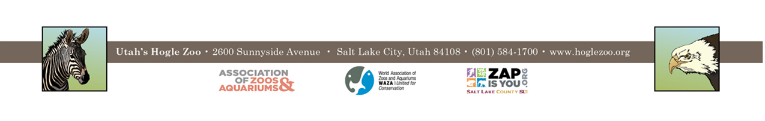

**REPORTS TO:** Utah Conservation Programs Supervisor

**DATES:** Option 1: Short term May 23rd 2022 – August 26th 2022 (3 months/ 14 weeks) or

Option 2: Long term May 23rd 2022– November 18th 2022 (6 months/ 27 weeks)

**POSITION DESCRIPTION:**

The main duty of the candidate will be to assist in boreal toad (*Anaxyrus boreas boreas*) research throughout the state of Utah. This will include field work, research, and literature development.

Intern duties include the following:

* Participate in wildlife monitoring activities- the majority of which will be amphibian- including; site visits, visual encounter surveys, PIT tag scanning, water quality measurements, radio tracking, habitat assessments and habitat restoration work
* Participate in our Jordan River conservation programs, including volunteer events, invasive species removal, planting and game camera maintenance.
* Attend meetings with partner organizations (Forest Service, Utah Division of Wildlife Resources)
* Help develop documents needed to support conservation and sustainability programs in various departments
* Help organize supplies for conservation projects and provide program support
* Document conservation field projects, data entry
* Keep an up to date weekly journal
* Assist with the Zoo’s recycling and sustainability program
* Opportunities to take part in related events/ online conferences/ online classes
* Opportunities to shadow zoo keepers, COVID depending

**QUALIFICATIONS:**

* Applicants must be currently enrolled in, or considered a recent graduate of an undergraduate or graduate program (sophomore standing or above).
* Internship open to all STEM majors.
* Students must be in good academic standing (2.5 GPA).
* Applicants must be able to stand for at least 3 hours, safely lift 40lbs and be capable of hiking an incline (1000ft/mile).
* Applicants must be comfortable driving a truck, camping together unsupervised, be familiar with camp cooking
* Applicants must be able to provide proof of a **negative** TB test and current tetanus vaccine as well as pass a drug test and background check.
* Must be eligible to work in the United States.
* Experience working in the field preferred, it is however essential the candidate enjoy working outdoors and camping.
* Demonstrated enthusiasm for and interest in working in the conservation field.

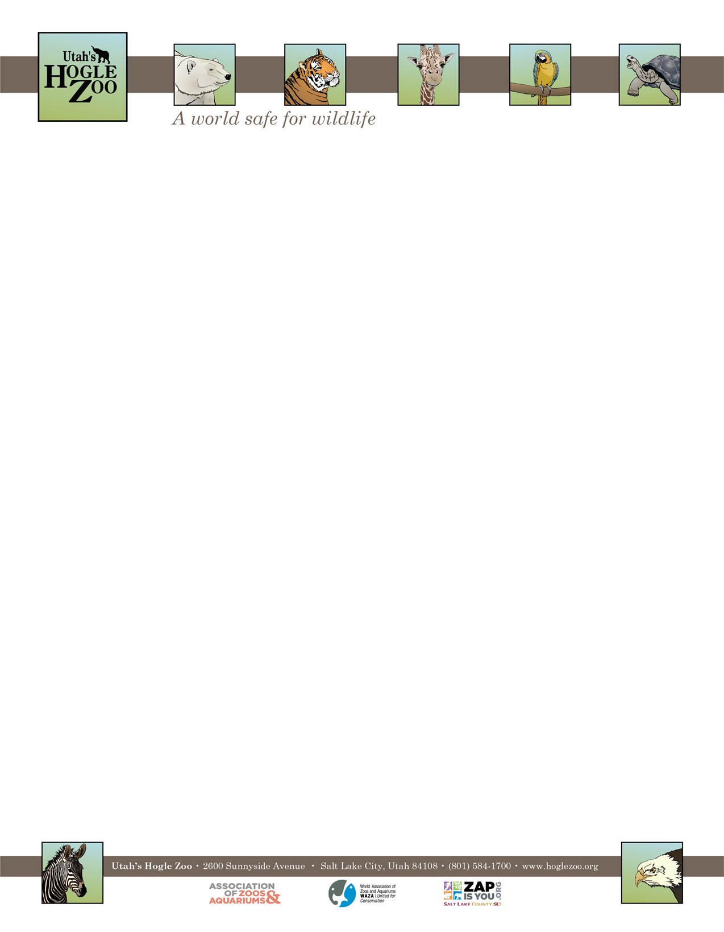

**QUALIFICATIONS CONTINUED:**

* Because of the nature of working in the field, the applicant needs to demonstrate maturity, self-motivation, and an ability to follow direction. In addition, an aptitude for hiking, ability to swim, a good level of fitness, and working in outdoor conditions must be demonstrated.
* A basic knowledge and understanding of Microsoft Office is helpful.
* Scholarship can only be awarded to individuals identifying as female, and all genders who are of one or more of the following ethnic minority classifications: African American, American Indian, Alaska Native, Native Hawaiian, Asian, Latino, Hispanic or Pacific Islander, as defined by The Beagle Conservation Scholarship.

**SCHEDULE:** 32-40 hours a week for a minimum of 13 weeks, dropping down to 8 – 16 hours for the longer term applicant. Interns may be scheduled to work on holidays and weekends and there will be multiple overnight trips.

**SCHOLARSHIP AWARD:**

**Dependent on Beagle Foundation Grant for 2022

*Utah’s Hogle Zoo is proud to announce the Beagle Conservation Scholarship.* The Diversity in Conservation Scholarship will provide a stipend for the duration of the internship (14 weeks, totaling $1500 or 27 weeks, totaling $3000). Thanks to the generosity of The Beagle Foundation, this scholarship provides to underrepresented groups, particularly women, the opportunity to study and participate in the field of conservation, through an unpaid internship with Utah’s Hogle Zoo.

**COMPENSATION:** This intern position is unpaid. Professional development opportunities will be available. Possible college credit is available for those able to receive it through their college/university. No housing is provided.

**TO APPLY:** Applications are due by **February 14th, 2022**.

Please visit <https://www.hoglezoo.org/jobs_volunteers/internships/> to fill out an application. In addition to completing the application send a resume, cover letter, and informal transcript to [volunteeroffice@hoglezoo.org](mailto:volunteeroffice@hoglezoo.org)  .

Please e-mail volunteeroffice@hoglezoo.org with any questions.

**Utah’s Hogle Zoo is committed to providing a diverse and inclusive internship program representative of a variety of backgrounds, age groups, perspectives, experiences, abilities, and strengths.**