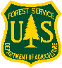 OUTDOOR WORK FOR MOTIVATED FUN PEOPLE!
If you like working with great people to build trails, educate the public, clear logs in wilderness, fix picnic tables (and much more), a job with the Forest Service Recreation Program might be for you.
In the middle of January the Uinta-Wasatch-Cache National Forest will be accepting applications for the 2018 summer season. Don’t miss your opportunity!

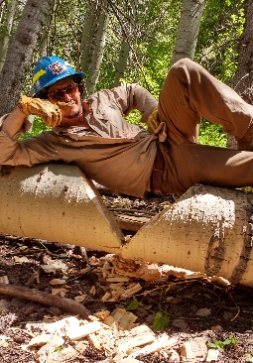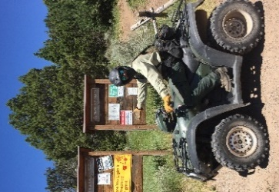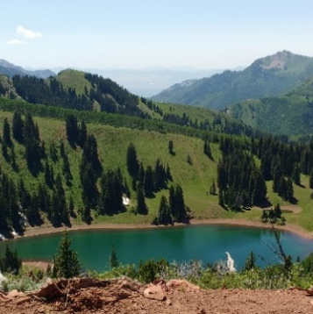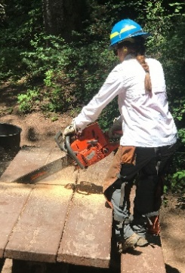
How to apply:
Now: Get ready to submit your application
- Update your resume. It can be as long as necessary to show your work skills, outdoor experience, leadership, passion.
- Check contact information for your references
- Visit the Forest Service Outreach Database (https://fsoutreach.gdcii.com/Outreach) to see when vacancies will be open, and which jobs and districts (https://www.fs.usda.gov/main/uwcnf/about-forest/districts) you want to apply to.
- Contact the local districts to ask about job details.
Mid-January: Submit your application during the one week its open!
- Search USAjobs.gov for keyword “Forestry” and your location (ex: “Salt Lake” or “Kamas”) or get the actual announcement number from the “Outreach Database”
- Give yourself enough time, be complete!
- Answer the application questions honestly, but don’t be too humble.
March: Let’s Talk
- We’ll be making calls to interview applicants and answer your questions
- You should get in touch with the district to let them know you’re still interested.
May: Let’s Go!
- Put on your boots, grab some tools, and let’s go get some work done on the Forest!

